IT 360 Cloud Integration | Week 1 | Lab 1
Migrate an Apache Web Server from AWS EC2 to Google Compute Engine
Student guide with console (UI) and command-line (CLI) steps
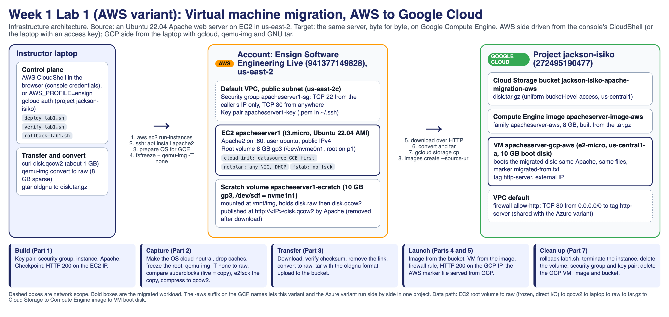
Figure 1. What you build: the same Apache server answers first on an AWS public IP, then on a Google Cloud public IP.
Ensign College | Instructor: Dr. Jackson Isiko | Version 2026-10-28
Time: about 2 hours of hands-on work. Every step has been run end to end on a real AWS account and a real Google Cloud project; the expected outputs in this guide come from those runs.

Contents
Section | Steps | Time
Before you start | Accounts, tools, naming table, the three rules | 10 min
Part 1. Build the Apache server in AWS | Steps 1 to 4, Checkpoint 1 | 25 min
Part 2. Capture the boot disk as a portable image | Steps 5 to 8, Checkpoint 2 | 25 min
Part 3. Transfer the image to Google Cloud | Steps 9 to 13 (Step 11 removes the public link) | 20 min
Part 4. Create the image and launch the VM in Google Cloud | Steps 14 and 15 | 15 min
Part 5. Open the firewall and validate | Steps 16 to 18, Checkpoint 3 | 15 min
Part 6. Troubleshooting | Symptom, cause, fix for every known failure | as needed
Part 7. Clean up | Both clouds, with the proof you submit | 10 min
Deliverables | What to hand in on Canvas
Appendix A and B | The lab as scripts; why not the vendor migration tools

Before you start

What you will do
You will build a Linux web server in AWS, capture its boot disk as a portable image, move that image to Google Cloud, and boot it as a Compute Engine VM. The server keeps its software and its files; only the cloud underneath it changes. This is the manual version of what migration tools such as Google's Migrate to Virtual Machines or AWS Transform do for you, so that you can see what is inside a migration before you let a tool hide it.
Phase | What happens | Where you work | You are done when
1 Build | Launch an Ubuntu VM with Apache; open port 22 to your IP only and port 80 to everyone | AWS console or CLI, then SSH | The Apache page opens on the AWS public IP
2 Prepare | Make the OS cloud-neutral so it can boot on Google Cloud | SSH on the EC2 instance | PREP_DONE is printed
3 Capture | Freeze the root disk, copy it, check the copy, compress it to a 1 GB qcow2, publish it over HTTP | SSH on the EC2 instance | The two Block count lines match and you have an md5
4 Transfer | Download the qcow2 into Google Cloud Shell, verify the md5, convert it to a raw tar.gz, upload it to a bucket | Google Cloud Shell | disk.tar.gz is in the bucket
5 Import | Create a Compute Engine image from the bucket, start a VM from the image, allow HTTP | GCP console or Cloud Shell | Image READY, VM RUNNING
6 Validate and clean up | Open the page on the GCP IP, prove it is the same server, remove the public link, delete everything | Browser, Cloud Shell, AWS | Both clouds show nothing left

How to read this guide
- Numbered steps are in order. Do not skip a step; later steps depend on earlier ones.
- A blue Console (UI) path box tells you what to click. A dark code block gives the same thing as commands. Use whichever you prefer; the result is identical. Steps that run inside the VM (Steps 6 to 8) are always commands over SSH.
- A green Expected result box tells you what you should see before moving on. If you do not see it, go to Part 6, Troubleshooting, before continuing.
- Replace every <PLACEHOLDER> with your own value from the naming table below. Type commands exactly; copy and paste from this document works.
- Checkpoints are screenshots you submit. There are three plus the cleanup proof.

Accounts and tools
You need | Details
AWS access | The course Vocareum AWS Sandbox works for every AWS step (region us-east-1, key pair vockey, instance type t2.micro). Your own AWS account also works (this guide uses us-east-2, t3.micro, a key pair you create).
Google Cloud project | A project where you can enable APIs, create buckets, images, VMs and firewall rules. A personal free-trial project is fine. The Vocareum Google Cloud Lab role cannot create firewall rules, so if you use it, follow the note in Step 16.
A terminal | AWS: the Vocareum terminal, AWS CloudShell in the console, or your laptop with the AWS CLI. Google: Cloud Shell (the >_ icon at the top right of the console). Cloud Shell already has gcloud, curl, tar and can install qemu-utils.
SSH client | Built in on macOS, Linux and Windows 10 or later (ssh in Terminal or PowerShell).
Browser | Any; you will open two public IPs and take screenshots.

Naming used in this guide
Write your real values in the right-hand column before you start, and keep this page open.
Item | Value in this guide | Yours
AWS region | us-east-2 (Ohio); Vocareum sandboxes use us-east-1
EC2 instance name | apacheserver1
EC2 public IP | <EC2_PUBLIC_IP>
EC2 instance ID | <INSTANCE_ID> (looks like i-0123456789abcdef0)
Key pair | apacheserver1-key (own account) or vockey (Vocareum, file ~/.ssh/labsuser.pem)
Security group | apacheserver1-sg: port 22 from your IP only, port 80 from anywhere
Scratch volume | 10 GiB gp3, device /dev/sdf
GCP project ID | <PROJECT_ID>
GCP bucket | <PROJECT_ID>-apache-migration-aws
GCP image | apacheserver-image-aws
GCP VM | apacheserver-gcp-aws, zone us-central1-a, e2-micro
GCP external IP | <GCP_EXTERNAL_IP>

Three rules
- Never open port 22 to the world. The security group allows SSH from your own IP only. If your IP changes (home networks do), edit the rule instead of widening it.
- The disk image is public only while you download it. Step 8 publishes it over HTTP; Step 11 removes it. Do Step 11 as soon as the download finishes.
- Delete everything at the end. Both clouds bill by the hour. Part 7 has the exact commands and the proof you submit.

Part 1. Build the Apache server in AWS (25 min)

Step 1. Launch an Ubuntu EC2 instance
Console (UI) path
1. In the AWS console, pick your region in the top-right selector: US East (Ohio) us-east-2 on your own account, or leave us-east-1 on Vocareum.
2. Go to EC2 → Instances → Launch instance.
3. Name: apacheserver1.
4. Application and OS Images: Ubuntu Server 22.04 LTS (HVM), SSD Volume Type, 64-bit (x86).
5. Instance type: t3.micro (t2.micro on Vocareum).
6. Key pair: Vocareum: choose vockey. Own account: Create new key pair named apacheserver1-key, type RSA, format .pem; the browser downloads the file. Move it to ~/.ssh/ and run chmod 400 ~/.ssh/apacheserver1-key.pem.
7. Network settings → Edit: VPC default, Auto-assign public IP Enable. Create security group named apacheserver1-sg with two inbound rules: SSH, source My IP; HTTP, source Anywhere-IPv4.
8. Configure storage: leave 8 GiB gp3.
9. Click Launch instance, open the instance, and write down the Public IPv4 address and the Instance ID.

CLI equivalent (Vocareum terminal, AWS CloudShell, or a laptop with the AWS CLI configured). On your own account change vockey to your key pair name:
MY_IP=$(curl -s -4 https://api.ipify.org)
VPC=$(aws ec2 describe-vpcs --filters Name=isDefault,Values=true --query 'Vpcs[0].VpcId' --output text)
SG=$(aws ec2 create-security-group --group-name apacheserver1-sg \
--description "SSH from admin and HTTP" --vpc-id $VPC --query GroupId --output text)
aws ec2 authorize-security-group-ingress --group-id $SG --ip-permissions \
"IpProtocol=tcp,FromPort=22,ToPort=22,IpRanges=[{CidrIp=$MY_IP/32}]" \
"IpProtocol=tcp,FromPort=80,ToPort=80,IpRanges=[{CidrIp=0.0.0.0/0}]"
AMI=$(aws ec2 describe-images --owners 099720109477 \
--filters 'Name=name,Values=ubuntu/images/hvm-ssd/ubuntu-jammy-22.04-amd64-server-*' \
--query 'sort_by(Images,&CreationDate)[-1].ImageId' --output text)
I=$(aws ec2 run-instances --image-id $AMI --instance-type t3.micro --key-name vockey \
--security-group-ids $SG --associate-public-ip-address \
--tag-specifications 'ResourceType=instance,Tags=[{Key=Name,Value=apacheserver1}]' \
--query 'Instances[0].InstanceId' --output text)
aws ec2 wait instance-running --instance-ids $I
aws ec2 describe-instances --instance-ids $I \
--query 'Reservations[0].Instances[0].[InstanceId,PublicIpAddress,Placement.AvailabilityZone]' --output text

Expected result
The instance shows Running with a public IPv4 address (the CLI prints the ID, the IP and the availability zone, for example i-01b8d04d847535524 18.191.11.26 us-east-2c). Write all three in your naming table.

Step 2. Connect over SSH
From your terminal (Vocareum terminal: the key is ~/.ssh/labsuser.pem):
chmod 400 ~/.ssh/apacheserver1-key.pem # Vocareum: chmod 400 ~/.ssh/labsuser.pem
ssh -i ~/.ssh/apacheserver1-key.pem ubuntu@<EC2_PUBLIC_IP>

Console (UI) path
The console shows the exact command: Instances → apacheserver1 → Connect → SSH client. You can also use EC2 Instance Connect in the same dialog if your security group allows it; the key-based ssh above always works.

Expected result
A prompt like ubuntu@ip-172-31-8-73:~$. Answer yes to the host-key question the first time. If it hangs for more than 30 seconds, your public IP is not the one in the security group: Security Groups → apacheserver1-sg → Edit inbound rules and set the SSH source to My IP again.

Step 3. Install Apache
sudo apt update -y
sudo apt install apache2 -y
sudo systemctl enable apache2
sudo systemctl start apache2

Step 4. Verify Apache in AWS
systemctl is-active apache2 # expect: active
curl -s -o /dev/null -w '%{http_code}\n' http://localhost/ # expect: 200

Open http://<EC2_PUBLIC_IP> in your browser.
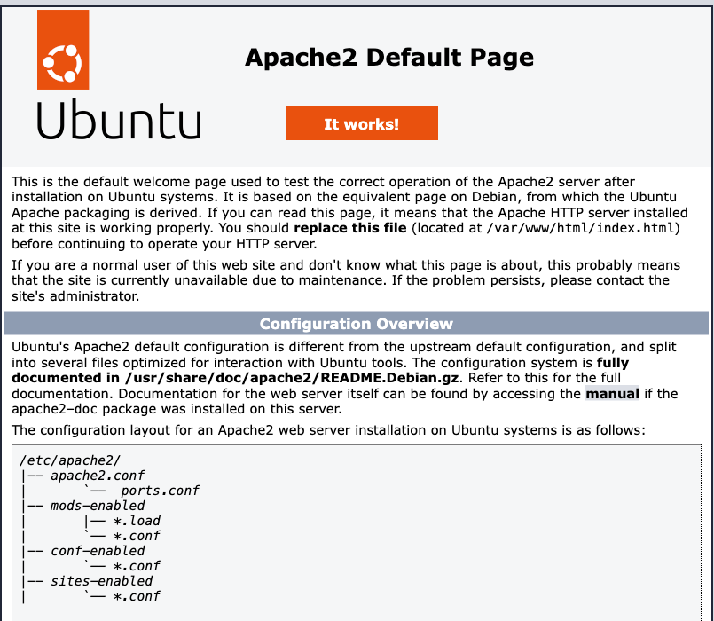
Figure 2. Checkpoint 1: the Apache default page on the AWS public IP.
Expected result
The page reads Apache2 Ubuntu Default Page: It works. Checkpoint 1: screenshot the browser with the AWS public IP visible in the address bar.

Part 2. Capture the boot disk as a portable image (25 min)
You cannot safely write an image of the root disk onto the root disk itself (it would fill up and the copy would include itself), so first attach a small scratch volume to hold the output.

Step 5. Attach a 10 GB scratch volume
Console (UI) path
1. EC2 → Instances → apacheserver1: note the Availability Zone (for example us-east-2c).
2. EC2 → Elastic Block Store → Volumes → Create volume: type gp3, size 10 GiB, Availability Zone = the instance's zone (a volume can only attach inside its own zone), tag Name = apacheserver1-scratch. Create volume.
3. Select the new volume → Actions → Attach volume → Instance apacheserver1, Device name /dev/sdf → Attach volume.

CLI equivalent (in the same AWS shell as Step 1):
I=<INSTANCE_ID>
AZ=$(aws ec2 describe-instances --instance-ids $I \
--query 'Reservations[0].Instances[0].Placement.AvailabilityZone' --output text)
V=$(aws ec2 create-volume --availability-zone $AZ --size 10 --volume-type gp3 \
--tag-specifications 'ResourceType=volume,Tags=[{Key=Name,Value=apacheserver1-scratch}]' \
--query VolumeId --output text)
aws ec2 wait volume-available --volume-ids $V
aws ec2 attach-volume --volume-id $V --instance-id $I --device /dev/sdf
echo "Scratch volume: $V"

Figure 3. The attach-volume output: state attaching, device /dev/sdf.
Expected result
Back in your SSH session, lsblk lists a new 10G disk: nvme1n1 on a t3 instance or xvdf on a t2 instance. Write down the volume ID; you delete it in Part 7.

Step 6. Prepare the OS for Google Cloud, then mount the scratch volume
An AWS Ubuntu disk boots on Compute Engine, but three AWS-specific settings would leave it without network or stuck at boot: cloud-init is pinned to the EC2 metadata service, netplan pins the network card by MAC address, and /etc/fstab asks for a disk check of the root at every boot. These five commands make the disk cloud-neutral. Run them in the SSH session on the EC2 instance:
printf "datasource_list: [ GCE, Ec2, None ]\n" | sudo tee /etc/cloud/cloud.cfg.d/99-multicloud.cfg
printf "network:\n version: 2\n ethernets:\n any:\n match:\n name: \"e*\"\n dhcp4: true\n" | sudo tee /etc/netplan/60-any-nic.yaml
sudo chmod 600 /etc/netplan/60-any-nic.yaml
sudo sed -i -E 's/(\s)0 1\s*$/\10 0/' /etc/fstab # no fsck at boot; the journal replays instead
sudo cloud-init clean --logs # the next boot behaves like a fresh instance
echo "migrated-from: AWS instance $(hostname) ($(curl -s -4 https://api.ipify.org)) captured $(date -u +%FT%TZ)" \
| sudo tee /var/www/html/migrated-from.txt
echo PREP_DONE

Then format and mount the scratch volume:
DEV=$(lsblk -dno NAME,SIZE | awk '$2=="10G"{print "/dev/"$1; exit}'); echo $DEV
sudo mkfs.ext4 -F $DEV && sudo mkdir -p /mnt/img && sudo mount $DEV /mnt/img
df -h /mnt/img

Expected result
PREP_DONE is printed, $DEV is /dev/nvme1n1 (t3) or /dev/xvdf (t2), and df -h /mnt/img shows about 9.8G free. The marker file migrated-from.txt is what later proves the GCP VM is the same server.

Watch out
Do the sed line exactly as written. It changes the last field of the root line in /etc/fstab from 1 to 0 (no boot-time fsck). You can check it with cat /etc/fstab; the root line must end in 0 0.

Step 7. Capture, check and compress the root volume
This step freezes the root filesystem for a few minutes, copies the whole root device straight from disk, thaws, confirms the copy has the same superblock as the live root, checks the copy, then compresses it. Paste the whole block into the SSH session:
sudo apt install -y qemu-utils
ROOT=/dev/$(lsblk -no PKNAME "$(findmnt -no SOURCE /)") # nvme0n1 on t3, xvda on t2
PART=$(findmnt -no SOURCE /) # nvme0n1p1 or xvda1
sudo sh -c "sync; echo 3 > /proc/sys/vm/drop_caches; blockdev --flushbufs $ROOT; fsfreeze -f /; \
qemu-img convert -T none -O raw $ROOT /mnt/img/disk.raw; fsfreeze -u /"
LOOP=$(sudo losetup -fP --show /mnt/img/disk.raw); N=$(echo "$PART" | grep -o "[0-9]*$")
LIVE=$(sudo dumpe2fs -h $PART 2>/dev/null | awk '/^Block count/{print $3}')
COPY=$(sudo dumpe2fs -h ${LOOP}p$N 2>/dev/null | awk '/^Block count/{print $3}')
echo "superblock block count: live=$LIVE copy=$COPY" # MUST be equal
sudo e2fsck -fy ${LOOP}p$N; sudo losetup -d $LOOP
sudo qemu-img convert -c -O qcow2 /mnt/img/disk.raw /mnt/img/disk.qcow2 && sudo rm /mnt/img/disk.raw
ls -l /mnt/img/disk.qcow2 # about 1 GB
md5sum /mnt/img/disk.qcow2 # write this down

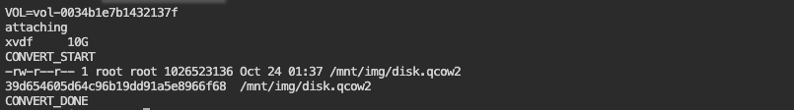
Figure 4. Checkpoint 2: the finished qcow2 with its size and md5.
Expected result
The copy takes 3 to 5 minutes on a t3.micro; the SSH session looks frozen during the raw copy, which is normal.
The line superblock block count: live=2068731 copy=2068731 has two equal numbers (yours may differ from 2068731, but the two must match). e2fsck ends with a summary line and no error. The qcow2 is about 1.0 to 1.2 GB.
Checkpoint 2: record the size in bytes and the md5 hash.

Watch out
If the two block counts differ (CAPTURE_STALE), do not continue: the copy's superblock is from before the disk was resized at first boot, and the migrated VM would panic at /sbin/init. Run sudo rm /mnt/img/disk.raw and repeat the block from sudo sh -c "sync; ...". This is why the commands drop the caches and read the device with -T none.

Note
Why these steps? fsfreeze stops writes so the copy is consistent. e2fsck on the copy (never on the live root) repairs the crash-consistent journal and the Resize inode not valid warning that every online-grown Ubuntu cloud image reports; without it, the first boot on Google Cloud stops in the initramfs. The qcow2 compression turns an 8 GB disk into about 1 GB.

Step 8. Publish the image for download
The simplest cross-cloud transfer for a lab is to serve the file from the Apache server you just built:
sudo chmod 644 /mnt/img/disk.qcow2
sudo ln -s /mnt/img/disk.qcow2 /var/www/html/disk.qcow2
curl -sI http://localhost/disk.qcow2 | head -1 # expect: HTTP/1.1 200 OK

Expected result
The file is now at http://<EC2_PUBLIC_IP>/disk.qcow2. Leave this SSH session open; you come back to it in Step 11 to remove the link.

Part 3. Transfer the image to Google Cloud (20 min)
Do this part in Google Cloud Shell: open the Google Cloud console, select your project in the top bar, and click the Activate Cloud Shell icon (>_) at the top right. Cloud Shell is a small Linux VM with 5 GB of disk, enough for the 1 GB image and its conversion.

Step 9. Enable the APIs and create a bucket
Console (UI) path
1. APIs & Services → Enabled APIs & services → Enable APIs and services: enable Compute Engine API and Cloud Storage API (both are usually already on).
2. Cloud Storage → Buckets → Create: name <PROJECT_ID>-apache-migration-aws, location type Region, region us-central1, storage class Standard, access control Uniform. Create.

CLI equivalent in Cloud Shell:
gcloud config set project <PROJECT_ID>
gcloud services enable compute.googleapis.com storage.googleapis.com
B=<PROJECT_ID>-apache-migration-aws
gcloud storage buckets create gs://$B --location=us-central1 --uniform-bucket-level-access

Expected result
Creating gs://<PROJECT_ID>-apache-migration-aws/... with no error. Bucket names are global, so if the name is taken add your initials and use that name everywhere below.

Step 10. Download the image into Cloud Shell and verify it
mkdir -p ~/lab1-import-aws && cd ~/lab1-import-aws
curl -f --retry 10 --retry-all-errors --retry-delay 5 -C - -O http://<EC2_PUBLIC_IP>/disk.qcow2
ls -l disk.qcow2
md5sum disk.qcow2 # must match Checkpoint 2

Expected result
The download takes 1 to 6 minutes depending on the link. The md5 printed here is identical to the one from Step 7. If it differs, delete the file and download again; the -C - option resumes a download that was interrupted.

Step 11. Remove the public download link in AWS
As soon as the md5 matches, go back to the SSH session on the EC2 instance (or open a new one) and run:
sudo rm /var/www/html/disk.qcow2
curl -s -o /dev/null -w '%{http_code}\n' http://localhost/disk.qcow2 # expect: 404

Console (UI) path
If you cannot reach the instance over SSH any more (your IP changed), Security Groups → apacheserver1-sg → Edit inbound rules and set the SSH source to My IP, then retry. The link must return 404 before you submit the lab.

Step 12. Convert to the Compute Engine raw format
Compute Engine builds images from a tar.gz that contains a single file named `disk.raw`, written with GNU tar in oldgnu format with sparse-file support. In Cloud Shell:
sudo apt-get install -y -qq qemu-utils
qemu-img convert -O raw disk.qcow2 disk.raw && rm disk.qcow2
tar --format=oldgnu -Sczf disk.tar.gz disk.raw && rm disk.raw
ls -lh disk.tar.gz # about 1 GB

Expected result
disk.tar.gz of about 1.0 to 1.1 GB. The intermediate disk.raw is 8 GB but sparse, which is why the -S flag matters.

Note
Doing this on your own laptop instead of Cloud Shell: macOS tar has no oldgnu format, so install GNU tar and QEMU first (brew install gnu-tar qemu) and use gtar in place of tar.

Step 13. Upload to Cloud Storage
gcloud storage cp disk.tar.gz gs://$B/disk.tar.gz
gcloud storage ls -l gs://$B/

Console (UI) path
Console alternative: Cloud Storage → Buckets → your bucket → Upload files and pick disk.tar.gz. This only works for a file on the machine where the browser runs, so use the gcloud command from Cloud Shell.

Expected result
The listing shows disk.tar.gz with the same size as in Step 12.

Part 4. Create the image and launch the VM in Google Cloud (15 min)

Step 14. Create the Compute Engine image
Console (UI) path
1. Compute Engine → Storage → Images → Create image.
2. Name: apacheserver-image-aws. Source: Cloud Storage file → Browse → your bucket → disk.tar.gz. Location: Multi-regional, us. Family: apacheserver-aws (optional).
3. Create. Wait for the status to become Ready (1 to 3 minutes). The size shows 8 GB.

CLI equivalent:
gcloud compute images create apacheserver-image-aws \
--source-uri=gs://$B/disk.tar.gz --family=apacheserver-aws \
--description="Migrated from AWS apacheserver1"
gcloud compute images describe apacheserver-image-aws --format="value(name,status,diskSizeGb)"

Expected result
apacheserver-image-aws READY 8. If gcloud prints gcloud crashed (ReadTimeout) after five minutes, the image is usually still created: run the describe command until it says READY, then continue.

Step 15. Launch the VM from the image
Console (UI) path
1. Compute Engine → VM instances → Create instance.
2. Name: apacheserver-gcp-aws. Region: us-central1. Zone: us-central1-a. Machine type: e2-micro.
3. OS and storage → Change: open the Custom images tab, pick apacheserver-image-aws, boot disk size 10 GB (it must be at least the image size, 8 GB). Select.
4. Networking: under Firewall, tick Allow HTTP traffic (this adds the network tag http-server and the default-allow-http rule if it is missing).
5. Create. Note the External IP in the instance list.

CLI equivalent:
gcloud compute instances create apacheserver-gcp-aws \
--zone=us-central1-a --machine-type=e2-micro \
--image=apacheserver-image-aws --boot-disk-size=10GB \
--tags=http-server
gcloud compute instances describe apacheserver-gcp-aws --zone=us-central1-a \
--format="value(status,networkInterfaces[0].accessConfigs[0].natIP)"

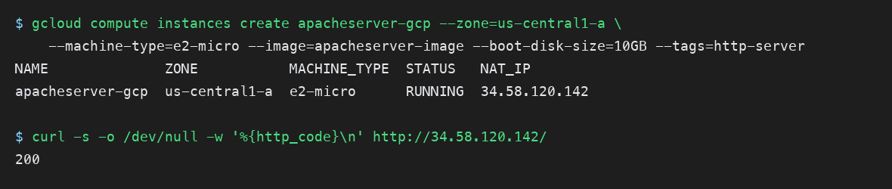
Figure 5. Step 15 output: the VM is RUNNING with its external IP, followed by the first HTTP 200.
Expected result
RUNNING and an external IP such as 136.64.162.16. Write it in your naming table as <GCP_EXTERNAL_IP>. The http-server tag is what the firewall rule in the next step matches on. As in Step 14, a ReadTimeout from gcloud does not mean the VM failed; the describe command tells you.

Part 5. Open the firewall and validate (15 min)

Step 16. Allow HTTP traffic in the VPC firewall
Skip this step if you ticked Allow HTTP traffic in Step 15 and gcloud compute firewall-rules list shows default-allow-http. Otherwise create the rule:
Console (UI) path
VPC network → Firewall → Create firewall rule: name allow-http, network default, direction Ingress, action Allow, targets Specified target tags = http-server, source IPv4 ranges 0.0.0.0/0, protocols and ports TCP 80. Create.

gcloud compute firewall-rules create allow-http --network=default \
--direction=INGRESS --action=ALLOW --rules=tcp:80 \
--source-ranges=0.0.0.0/0 --target-tags=http-server
gcloud compute firewall-rules list

Note
On the Vocareum Google Cloud Lab the command fails with Required 'compute.networks.updatePolicy' permission. That role cannot create firewall rules. Check whether default-allow-http already exists (gcloud compute firewall-rules list); if it does, the http-server tag from Step 15 is enough. If it does not, complete Parts 3 to 7 in a personal Google Cloud project, as the prerequisites say.

Step 17. Validate from the outside
IP=$(gcloud compute instances describe apacheserver-gcp-aws --zone=us-central1-a \
--format="value(networkInterfaces[0].accessConfigs[0].natIP)")
for i in $(seq 1 20); do curl -s -m 5 -o /dev/null -w "%{http_code}\n" http://$IP/ && sleep 10; done | uniq
curl -s http://$IP/migrated-from.txt

Open http://<GCP_EXTERNAL_IP> in your browser, then http://<GCP_EXTERNAL_IP>/migrated-from.txt.
Console (UI) path
Compute Engine → VM instances: the External IP column is a link that opens the page. Then apacheserver-gcp-aws → Logs → Serial port 1 (console): find the line cloud-init ... finished ... Datasource DataSourceGCE and make sure there is no fsck failure and no Kernel panic.

Expected result
000 for the first 20 to 40 seconds while the VM boots, then 200. The browser shows the same Apache2 Ubuntu Default Page, and migrated-from.txt names your EC2 instance and its IP, which proves this is the disk you captured and not a new install.
Checkpoint 3 (part 1): screenshot the Apache page with the GCP external IP in the address bar.

Step 18. Validate from the inside
The migrated disk does not yet contain Google's guest agent, so the SSH keys that gcloud compute ssh would push are not applied. The image still trusts your AWS key pair, so use it. First allow SSH from your own IP only:
MY_IP=$(curl -s -4 https://api.ipify.org)
gcloud compute firewall-rules create allow-ssh-admin --network=default \
--direction=INGRESS --action=ALLOW --rules=tcp:22 \
--source-ranges=$MY_IP/32 --target-tags=http-server

Then, from the machine that holds the AWS .pem file (upload it to Cloud Shell with the ⋮ menu → Upload if needed):
ssh -i ~/.ssh/apacheserver1-key.pem ubuntu@<GCP_EXTERNAL_IP> # Vocareum key: ~/.ssh/labsuser.pem
hostname; systemctl status apache2 --no-pager | head -3
cat /var/www/html/migrated-from.txt
sudo apt-get install -y google-guest-agent google-compute-engine # optional: enables gcloud compute ssh

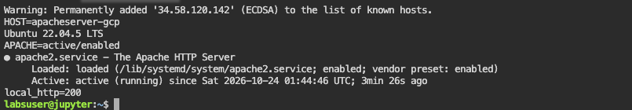
Figure 6. Checkpoint 3: Apache active inside the GCP VM.
Expected result
The hostname is now apacheserver-gcp-aws (cloud-init renamed it on the first Google boot) while the marker file still names the AWS instance. systemctl status apache2 shows active (running).
Checkpoint 3 (part 2): screenshot this terminal output.

Note
A REMOTE HOST IDENTIFICATION HAS CHANGED warning means the IP was used by an earlier VM of yours; run ssh-keygen -R <GCP_EXTERNAL_IP> and retry. After the guest agent is installed, gcloud compute ssh ubuntu@apacheserver-gcp-aws --zone=us-central1-a also works.

Part 6. Troubleshooting
Find your symptom in the left column. Every row below was hit at least once while this lab was being built.
Symptom | Likely cause | Fix
Step 2: ssh hangs, then Operation timed out | Your public IP is not the one in the security group (home and campus networks change it) | Edit the SSH rule's source to My IP again; never widen it to 0.0.0.0/0
Step 3: Could not get lock /var/lib/dpkg/lock-frontend | Ubuntu's unattended-upgrades is still running on a fresh instance | Wait a minute and repeat the apt command
Step 5: lsblk shows no 10G disk | Volume created in a different availability zone, or not attached | Create it in the instance's zone; attach as /dev/sdf
Step 7: qemu-img: command not found | Package missing | sudo apt install -y qemu-utils
Step 7: No space left on device | Writing to the root disk instead of the scratch volume | Check df -h /mnt/img; repeat Step 6's mount commands
Step 7: block counts differ (CAPTURE_STALE) | The copy read a stale whole-disk cache | Delete disk.raw and repeat the capture block; the cache drop and -T none are mandatory
Step 10: curl gets 404 | Symlink not created, or wrong IP | Repeat Step 8 and confirm with curl -I http://<EC2_PUBLIC_IP>/disk.qcow2
Step 10: download stops part way, curl exits | Flaky network | Run the same curl again; -C - continues the file
Step 10: md5 differs | Partial or corrupted download | rm disk.qcow2 and download again
Step 12: Can't use format oldgnu | BSD tar (macOS) | Use Cloud Shell, or brew install gnu-tar and gtar
Step 14: images create fails: not a valid tar, or file not named disk.raw | Wrong tar format or file name | Repeat Step 12 exactly
Step 14 or 15: gcloud crashed (ReadTimeout) | Slow link; the API finished but the client gave up after 300 s | Run images describe or instances describe; continue when READY or RUNNING
Step 15: Requested disk size cannot be smaller than the image size | Boot disk smaller than the image | Use --boot-disk-size=10GB or larger
Step 17: browser times out on the GCP IP | No firewall rule, or VM lacks the http-server tag | Step 16; gcloud compute instances add-tags apacheserver-gcp-aws --zone=us-central1-a --tags=http-server
Step 17: serial console shows Polling IMDS or DataSourceEc2 retries, no network | Step 6 was skipped, so cloud-init still looks for AWS | Go back to the EC2 instance, run Step 6, repeat Steps 7 to 15
Step 17: initramfs prompt UNEXPECTED INCONSISTENCY | Copy made without the e2fsck of Step 7 | Repeat Step 7 including e2fsck, then Steps 8 to 15
Step 17: Kernel panic ... can't execute '/sbin/init' | A stale-superblock copy was imported | Delete the VM and image; repeat Step 7 and check the two block counts
Step 18: Permission denied (publickey) with gcloud compute ssh | Guest agent not installed yet | SSH with the AWS key as shown, then install the agent
Step 16: Required 'compute.networks.updatePolicy' permission | Your account cannot create firewall rules in this project | Use a personal project, or rely on default-allow-http if it exists
Sandbox: export-image task goes to deleted; iam:CreateUser denied by SCP | Vocareum policy blocks VM Import/Export and IAM users | Expected; this lab's method does not need them

Part 7. Clean up (10 min)
Everything below is billable until deleted. Do AWS and Google Cloud both, then run the two proof commands and keep their output for your submission.

AWS
Console (UI) path
1. EC2 → Instances → apacheserver1 → Instance state → Terminate instance. Wait for Terminated.
2. Volumes → apacheserver1-scratch → Actions → Delete volume (the 8 GiB root volume is deleted with the instance).
3. Security Groups → apacheserver1-sg → Actions → Delete security groups.
4. Own account only: Key Pairs → apacheserver1-key → Actions → Delete.

aws ec2 terminate-instances --instance-ids <INSTANCE_ID>
aws ec2 wait instance-terminated --instance-ids <INSTANCE_ID>
aws ec2 delete-volume --volume-id <SCRATCH_VOLUME_ID>
aws ec2 delete-security-group --group-name apacheserver1-sg
aws ec2 delete-key-pair --key-name apacheserver1-key # own account only
aws ec2 describe-instances --filters Name=instance-state-name,Values=running \
--query 'Reservations[].Instances[].[InstanceId,Tags[?Key==`Name`].Value|[0]]' --output table # proof

Google Cloud
Console (UI) path
1. Compute Engine → VM instances → apacheserver-gcp-aws → Delete.
2. Compute Engine → Images → apacheserver-image-aws → Delete.
3. Cloud Storage → Buckets → your bucket → Delete (type the name to confirm).
4. VPC network → Firewall → allow-http and allow-ssh-admin → Delete.

gcloud compute instances delete apacheserver-gcp-aws --zone=us-central1-a --quiet
gcloud compute images delete apacheserver-image-aws --quiet
gcloud storage rm -r gs://$B
gcloud compute firewall-rules delete allow-http allow-ssh-admin --quiet
gcloud compute instances list; gcloud compute images list --no-standard-images; gcloud storage ls # proof

Expected result
The AWS proof table is empty (or lists only instances that are not yours), and the three Google Cloud lists show nothing from this lab. Cleanup proof: copy both outputs into your submission.

Deliverables
Submit one PDF or document on Canvas containing:
- Checkpoint 1: the Apache page on the AWS public IP (Step 4).
- Checkpoint 2: the image size and md5 from the EC2 instance (Step 7) and the matching md5 from Cloud Shell (Step 10).
- Checkpoint 3: the Apache page on the GCP external IP and migrated-from.txt (Step 17), plus systemctl status apache2 from inside the GCP VM (Step 18).
- Cleanup proof: the output of the proof commands from Part 7, and the 404 from Step 11.
- Reflection, three to five sentences: what in the disk had to change for the server to run on Google Cloud (Step 6), what the two block-count numbers in Step 7 protect you from, and what would be different if you had used Google's Migrate to Virtual Machines connector instead.

Appendix A. The same lab as scripts
The course repository folder Week 1 labs/aws-to-gcp-vm-migration/scripts/ contains every command above as runnable scripts. They are useful once you have done the lab by hand and want to repeat it, and they are what the instructor uses to rebuild the demo. Read a script before running it.
Script | Where to run | Covers
01-aws-build-apache.sh | Vocareum terminal or any AWS CLI shell | Steps 1 to 4
02-aws-attach-scratch-volume.sh | Same AWS shell | Step 5
03-ec2-make-image.sh | On the EC2 instance over SSH | Steps 6 to 8
00-aws-all-in-one.sh | AWS CloudShell or a laptop with credentials | Steps 1 to 8 in one run, with the superblock check
04-gcp-import-and-launch.sh <PROJECT_ID> <EC2_PUBLIC_IP> | Cloud Shell or laptop with gcloud | Steps 9, 10, 12 to 17 (resumable download, waits for READY and RUNNING)
05-cleanup-aws.sh, 06-cleanup-gcp.sh <PROJECT_ID> | AWS shell; Cloud Shell | Part 7 by name; -n lists only, -y skips the prompt

Measured on 2026-10-27 with a fast link: AWS build and capture 7 minutes, transfer and Google Cloud launch 10 minutes, 17 minutes in all. On a slow home link the download and upload steps dominate (37 minutes the same evening at 2 MiB/s), so start the transfer early.

Appendix B. Why not AWS's own export and Google's Migrate to VMs?
AWS can export an AMI to a VMDK in S3 (aws ec2 export-image), and Google's Migrate to Virtual Machines can connect to an AWS account and replicate instances directly. Both are the right tools for a fleet. Both also need things a teaching sandbox refuses: the export needs the vmimport IAM role and an S3 bucket (the Vocareum sandbox deletes the export task within seconds), and the connector needs a long-lived IAM user access key (the sandbox denies iam:CreateUser through an organization policy). The method in this guide needs only SSH to the instance and normal Compute Engine permissions, and it shows you exactly what a migration tool changes: the cloud-init datasource, the network configuration, the boot-time disk check, and the guest agent.

